India-UN Fund Project Completion Report

Haiti
Improving access to water through the installation of solar pumping systems
August 2020- August 2023

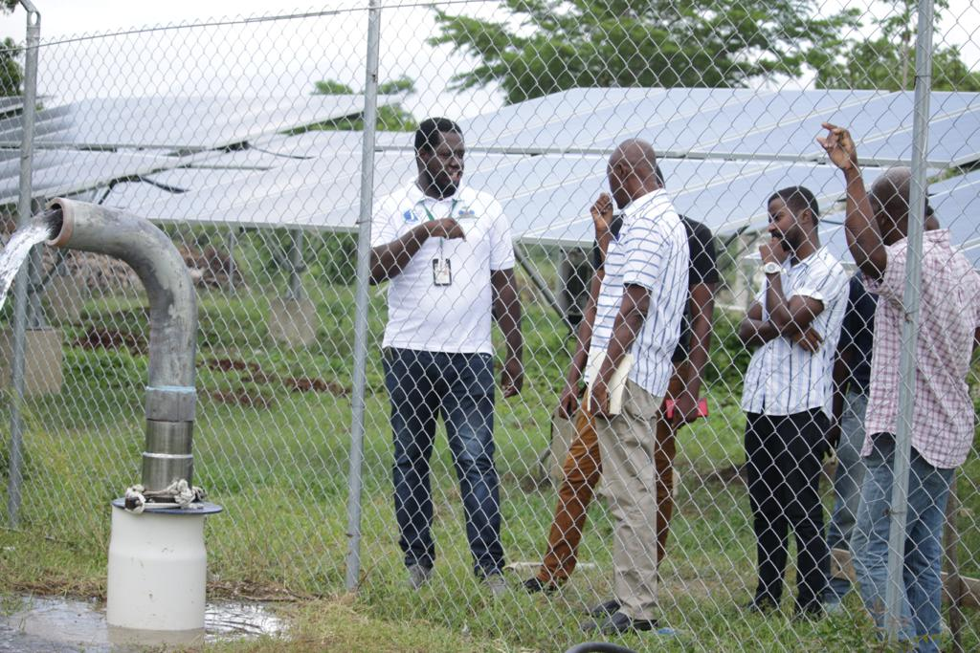

Project Title |  | Improving access to water through the installation of solar pumping systems
Project country/countries |  | Haiti
Project start date (dd/mm/yyyy) |  | 01/08/2020
Project end date (dd/mm/yyyy) |  | 31/08/2023
Reporting Period
Implementing Partner(s) |  | Ministry of Environment and UNDP Haiti
Total resources required (USD) |  | 1,000,000.00
Total revenue received (USD) |  | 1,060,000.00
 | India-UN Fund (USD) | 1,000,000.00
 | Other contributions (USD) | 60,000 (UNDP)
Unfunded budget (USD)
Project Contact Person  (Name, Title and Email) |  | Pierre Claude Dumeus, Technical Assistant  pierre-claude.dumeus@undp.org
Report Reviewed and Submitted by (Name, Title and Email)  * Country Office Senior Management is expected to clear or submit the report. |  | Dorine Jn Paul, Program Specialist, dorine.jn.paul@undp.org

Table of Content
1) Executive summary
2) Background
3) Results review and reporting
3.a. Analysis of results
3.b. Direct and indirect beneficiaries of the project
3.c. South-South cooperation
3.d. Key highlights of evaluation/review
3.e. Progress on project log-frame outcome and output indicators
4) Lessons learned
5) Sustainability/Post-Project Continuity of Results
Annexes

1) Executive summary
The project has two major phases: the drilling of the wells and the installation of the solar water pumping systems. Despite of the tense situation in the recent years in Haiti, the implementing partners – the Ministry of Environment of Haiti (MOE) and the United Nations Development Program (UNDP)- have worked together with local authorities and private firms for completing the project. Firstly, a contract has been signed for the drilling of the wells. As a result, 8 wells have been drilled. Secondly, another contract has been signed for purchasing, installing, and commissioning 8 solar water pumping systems, meanwhile other activities such as capacity building program for the benefit of the local managing committees were being conducted until the end of August. Both contracts for the construction part have faced severe delays due to custom and transportation difficulties. Indeed, the project implementation areas have been severely affected by gang activities located in the southern region of the capital, Port-au-Prince. However, all the “hard works” have been completed and the systems are commissioned.

2) Background
The project “Improving Access to Water through the Installation of solar water pumping systems” initially planned to respond to the priorities of the National Determined Contribution (NDC) of 2015 and to the priorities identified in the NATIONAL ADAPTATION ACTION PLAN by giving access to water to farmers and households in the regions of Aquin and Baconnois in the South and Nippes departments through the installation of 7 solar photovoltaic water pumping systems, and at the same time help to avoid greenhouse gas emissions. Due to the high demand, another system has been added for the benefit of another municipality which is the municipality of Fond-des-Negres in Les Nippes despite funding constraints. Therefore, the project has installed 8 systems in 3 municipalities: Aquin, Anse-a-Veau and Fond-des-Negres. However, the socio-economic situation in Haiti had caused time extension of 18 months.
The installation and commissioning of the 8 water pumping systems is improving women and girls' access to water and the irrigation capacity of agricultural lands. Attention has been paid to the engagement of women, young people and people with reduced mobility in the social management of water in the project area. For each system, a local committee has been created for the local management of the systems.

3) Results review and reporting:
3.a. Analysis of results
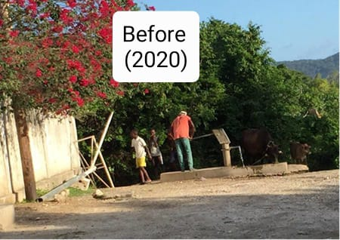
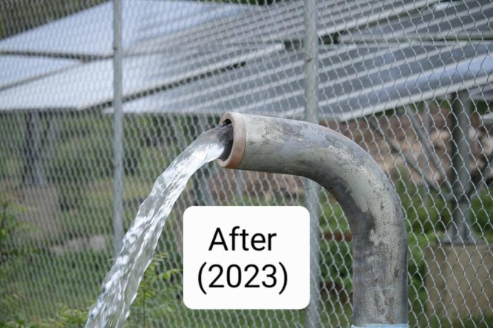

Access to water has always been very difficult in rural communities in Haiti. In Aquin, Baconnois and Fonds-Des-Nègres, few manual water pumps with a very low flow existed before the project. These small manual systems were used to pump water for household use and for feeding the cattle. Water users especially in Baconnois often traveled for miles to collect water. The project actually allows around 40 000 people in 3 municipalities to have access to water through the commissioning of 8 sustainable solar water pumping systems. The water is being used for sanitation and irrigation.

3.b. Direct and indirect beneficiaries of the project

i) Direct beneficiaries: those who receive dedicated support from projects (e.g., recipients of grants, agricultural inputs; users of water facilities, health services, vocational training, etc.).

Number of people directly receiving support through South-South trust-fund projects
Disaggregation | Total Achievement
Number of male | 18 800
Number of female | 21 200

ii) Indirect beneficiaries: those who do not receive direct support from the project but are still impacted by some activities (e.g., inhabitants of project catchment area who benefit from the projects/initiatives, participants of online workshops/meetings, webinars etc.).

Number of people indirectly benefiting through South-South trust-fund projects
Disaggregation | Total Achievement
Number of male | 19 173
Number of female | 21 481

3.c. South-South cooperation
i.) South-South cooperation indicators
Indicator | Actual achievement in reporting quarter | Comments if applicable
Number of examples of good practices in South-South cooperation transferred to developing countries with support by the India-UN Fund project  (please attach available documentation or details – as applicable) | 1 | Partnership which allows technology transfer has been created between Indian firm and local Haitian firm.
Number of South-South cooperation knowledge exchanges supported/facilitated by the India-UN Fund project  (please attach available documentation or details – as applicable) | 1 | Discussions on the challenges and opportunities of the green energies for Haiti and on the expected outputs of the project for rural communities in Haiti have been held during a symposium bringing together private sector, public sector, and donors. The project is seen as an excellent and concrete example of putting into action the Water-Energy-Food security nexus.
Number of evidence-based good practices documented based on the achievements of the India-UN Fund projects  (please attach available documentation or details – as applicable) | 1 | Based on the project activities and achievements, an exchange Forum has been organized to offer local and national actors the opportunity to discuss about the importance of groundwater management and usage and the challenges they are facing. It has been recognized as a good practice by the scientific and social members of the workshops. A communication article on UNDP webpage and different social media is available by clicking here .

ii) Description of achievements related to South-South cooperation
As key action taken by the project in strengthening South-South cooperation, the facilitation of the establishment of a reliable partnership between the well-experienced Indian firm -SHAKTI PUMPS- and Haitian technicians including the local firm for implementing the project has created an effective knowledge transfer channel by which local technicians are getting necessary skills for modeling and then replicating such kinds of solar water pumping project. Furthermore, the participation of the project in symposium on the green energies contributes to promote the reliable results of the cooperation existing between India and Haiti. Based on the project activities and achievements, an exchange Forum has been organized to offer local and national actors the opportunity to discuss about the importance of groundwater management and usage and the challenges they are facing. It has been recognized as a good practice by the scientific and social members of the workshops. A communication article on UNDP webpage and different social media is available by clicking here .

3.d. Key highlights of evaluation/review
No particular issue raised during Audit and evaluation

3.e Progress on Project Log-frame outcome and output indicators
Provide performance data on outcome and output level log-frame indictors of your Project. Provide self- assessed color coding [Red-Amber-Green (RAG)] on the suggested column in line with a RAG ‘Traffic Light’ rating.
GREEN | On track – 85%+ progress towards achievement of planned target for the year.
AMBER | At risk – 65-84% progress towards achievement of planned target for the year. Project team needs to identify particular measure(s) to overcome the low performance.
RED | Off track – progress below 65% towards achievement of planned target for the year. If two or more indicators are at risk, this scenario comes under serious concerns, and it should be escalated to the Management. This needs immediate attention with an action plan.

Result statements | Indicators | Baseline | Overall Project Target | Overall progress | RAG Rating | Comments on variations
Output 1  Solar-powered water pumping systems are installed in target communities | Number of solar PV water pumping units installed | 0 | 7 | 8 |  | Completed  8 systems have been installed and commissioned.
 | Number or % of girls or women heads of household identified, consulted and involved in the implementation of project activities | 0 | 60 | 60 |  | Completed
 | Number of women and men trained for the proper management and use of pumping systems | 0 | 20 | 20 |  | Completed

4) Challenges and Lessons Learned
- Need of an integrated water resource management: An Integrated water resource management approach in project design should be context driven. Factors such as water scarcity, water contamination, saltwater intrusion or significant water resource over allocations should trigger more exhaustive resource assessments during project preparation. Otherwise, basic but competent assessments of water availability and salient water quality issues are required.
- Community participation: It is only through participation that communities will get a sense of ownership and should, therefore, feel motivated to operate and maintain the system. In order to achieve meaningful community participation, projects need to adopt flexible policies and procedures that allow communities to explore ideas and make their own decisions.
- Partnerships and co-operation: There is an increasing need for actors to adapt in order to encourage and create partnerships with the national and local governments, and the private sector. These partnerships with the service providers are crucial to provide projects with the continuity that is needed to develop sustainable solutions.
- Project planning and timescale: Involving communities in identifying and planning projects is time-consuming and cannot be rushed. The traditional hardware-driven approach to water and sanitation projects does not allow time for community consultation or participation. A community-based approach requires a much longer lead-in time and implementing partners must have a long-term commitment to see the project through. This is particularly important when working with poorer communities who may be lacking in organizational structure and need more capacity building. Donors also need to understand the need for longer-term funding to achieve sustainable projects.

5) Sustainability/Post-Project Continuity of Results
For ensuring its sustainability, the project has adopted two approaches/strategies. First of all, since the project launching, we have prioritized the involvement and engagement of the stakeholders. The application of the stakeholder engagement plan elaborated since the beginning is contributing to the appropriation/ownership of the project results by local communities: households including girls and women, farmers, etc. Secondly, the capacity building activities through the training on maintenance and installation of solar pumping systems planned for the benefit of local women/men and other staffs of the project is to ensure that the achievements sustain over years and generations. At least, 20 women and men are trained this year for the proper operation of the systems.

6) Expenditure reporting
- UNDG HACT reporting agencies report through Funding Authorization and Certificate of Expenditures (FACE) Forms;
- UNEX reporting agencies report through Project Delivery Reports (PDRs);
- UNDP offices may attach a Consolidated Delivery Report (CDR) for the reporting year.

Annex:
- Photographs in action should be submitted through SharePoint. Upon request, UNOSSC can create and share a project folder.
 photo-sharing folder
- Human-interest story (at least one)
- Pompage d’eau solaire pour une mise en relief du nexus Eau-Energie-Alimentation | Programme De Développement Des Nations Unies (undp.org).
- Rural communities in Haiti gain access to water through solar water pumps
- FREPA22 : UNE PARTICIPATION REMARQUÉE DU PNUD ET DE SES PARTENAIRES POUR PROMOUVOIR L’ACCÈS DES COMMUNAUTÉS LES PLUS VULNÉRABLES À L’EAU ET AUX ÉNERGIES RENOUVELABLES
- L’INDE, LE PNUD ET LE MINISTÈRE DE L’ENVIRONNEMENT AMÉLIORENT L’ACCÈS À L’EAU POUR L’ASSAINISSEMENT ET LA PRODUCTION AGRICOLE EN HAÏTI

